July 30, 2026
FIRSTNAME LASTNAME
ADDRESS
Canton, OH 4470X

Citation to Appear Before the Board of Health

Dear <Greeting>:

On <Inspection Date>, an inspection was made of your property located at <Subject Address>, Canton, Ohio. At this time there was an <Nuisance Description> in violation of the Canton City Health Code. Such conditions are in violation of section 3707.01 of the Ohio Revised Code and are a threat to the public health, safety, and welfare.

Based on this information you are hereby ordered to appear before the Board of Health of the Canton City Health District at their special meeting on <Bd. Hearing Date & Time> to show cause why the Board should not furnish the materials and labor necessary to abate the public health nuisance at this property. The cost of abatement by the Board would be placed as a lien against the property to be collected as regular taxes.

The Board of Health meets in the offices of the Canton City Health Department, 420 Market Avenue North, Canton, Ohio. You may be represented at this hearing by yourself or by legal counsel. Failure to attend this hearing may result in the Board of Health rendering a decision in your absence. If you have any questions regarding this citation, please contact please contact Mark H. Adams, RS, MPH at 330-489-3327 or via email at madams@cantonhealth.org.

By Order of the Health Commissioner
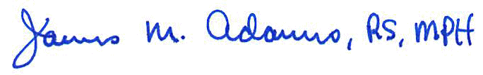
Authority: ORC 3707.02
James M. Adams, RS, MPH
Health Commissioner

<Case No.>

NOTE: If violations are corrected prior to the board meeting then board action can be reconsidered.

